US Grade 2 – Pre-test
11 Questions | 30-45 minutes | Calculator not allowed
1. Write these numbers in words.
4567:
_________________________________________________________________________
607:
_________________________________________________________________________
2. Write these numbers in orders, starting with the smallest.
2456, 2450, 2540, 2405
_________________________________________________________________________

3. Write a written method to perform the following additions and subtractions.
7890 + 3405 | 3842 + 439
6843 - 3562 | 4391 – 2186

4. Calculate the following multiplication problems.
5 × 3 = | 4 × 11 =
3 × 9 = | 10 × 3 =
2 × 8 = | 8 × 6 =
5. Write these equivalent lengths.
150 cm = __________________ m | 33 cm =__________________ mm
6. Partition the rectangles into fraction amounts.
Partition in half.
Partition into thirds.
Partition into quarters.

7. Write the missing fraction in the box on the number line.
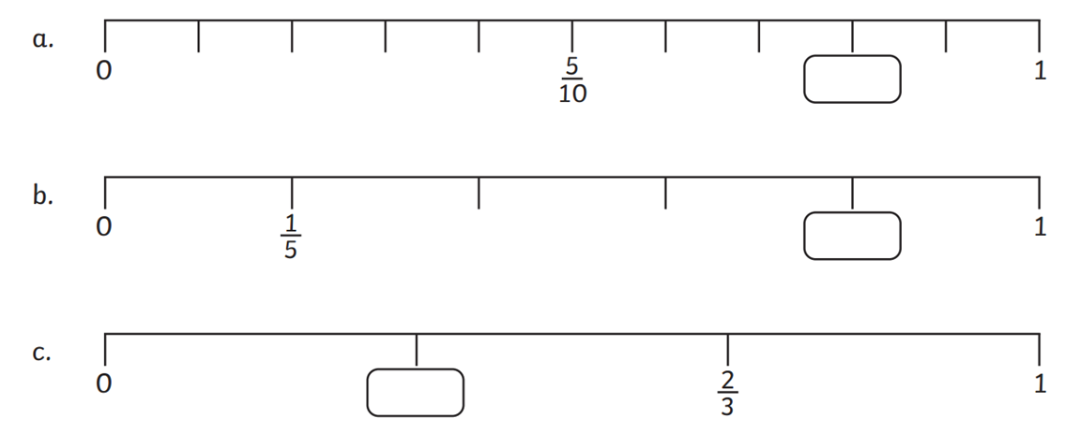
8. Fill in the blanks
2 minutes = ___________ seconds | 120 minutes =____________hours
9. Work out the number pattern.
634, 637, 640, ____________, ____________, ____________
30, 28, 26, ____________, ____________, ____________
10. Use the data to answer the questions.
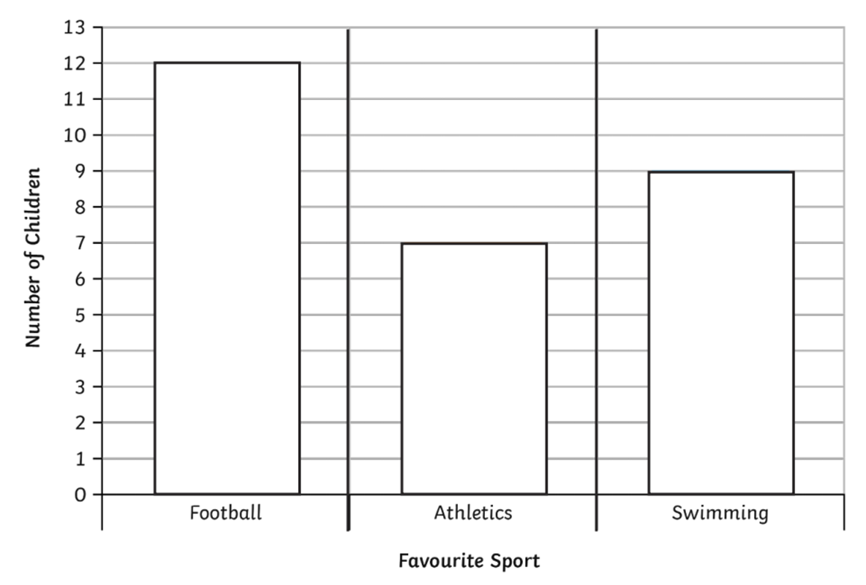
How many children preferred football? | ________________
How many more children like swimming more than athletics? | ________________
How many children voted? | ________________
Use the information below to answer questions 11-12.
The manager of a school cafeteria ordered some new kitchen supplies. He ordered 15 boxes of napkins, 3 boxes of paper cups, and 5 boxes each for plastic forks, knives, and spoons.
11. If there are 5 stacks of paper cups in each box, how many stacks of paper cups did he order?
____________________________________ stacks.
12. What fraction of the order is napkins?
____________________________________

